“Real time Iss tracking and marking on Earth’s Map”

A GDG 2cc project Report

submitted by

Shubham Kumar

16BCE0044

in partial fulfillment for the award of the degree of

B.TECH

in

COMPUTER SCIENCE AND ENGINEERING




SCHOOL OF COMPUTER SCIENCE AND ENGINEERING

MARCH & 2018-2019

DECLARATION BY THE CANDIDATE

I hereby declare that the project report entitled “Real time Iss tracker and marker on Earth’s Map” submitted by me to Vellore Institute of Technology, Vellore in partial fulfillment of the requirement for the award of the course of “Open Source Development for Google Applications” EXC1081 in GDG.

I would like to thank gdg for supporting and guiding us throughout the year and helping us learn and produce something out of the blue.

Name: Shubham Kumar
Reg Number: 16BCE0044

TABLE OF CONTENTS

CHAPTER NO. | TITLE | PAGE NO.
 | LIST OF TABLES | xvi
 | LIST OF FIGURES | xviii
 | LIST OF SYMBOLS | xxvii
1. | PROJECT | 3
 | 1.1 Abstract | 4
 | 1.2 Introduction | 4
 | 1.2.1. ISS | 4
 | 1.3Methodology | 5
 | 1.3.1 flow diagrams and code description | 5
 | 1.4 Result of execution | 10
 | 1.5 Conclusion and references | 11
 | 1.6 Appendix | 12

1.1 ABSTRACT

In this project, I, have created a system that Finds the details of people who are currently on the International Space Station and mark the current position of the ISS overhead Earth’s map.

The information of astronauts on international space station and ISS’s current location in the space in latitude and longitude is being provided by an api that I have used in this project.

This project makes it very easy to track down the current location and trajectory of the Iss.

1.2 INTRODUCTION

1.2.1 ISS and its role in our project.

The International Space Station (ISS) is a space station, or a habitable artificial satellite, in low Earth orbit. Its first component was launched into orbit in 1998, with the first long-term residents arriving in November 2000. It has been inhabited continuously since that date.

The station is expected to operate until 2030. The ISS is the largest human-made body in low Earth orbit and can often be seen with the naked eye from Earth. The ISS serves as a microgravity and space environment research laboratory in which crew members conduct experiments in biology , human biology, physics, astronomy, meteorology, and other fields. The station is suited for the testing of spacecraft systems and equipment required for missions to the Moon and Mars. The ISS maintains an orbit with an altitude of between 330 and 435 km (205 and 270 mi) by means of reboost manoeuvres using the engines of the Zvezda module or visiting spacecraft. It circles the Earth in roughly 92 minutes and completes 15.5 orbits per day that is approx. 500kmph.

There are some 6 astronauts currently on the space station and this project is to track and mark them on the map of earth based on the location data retrieved from the api http://api.open-notify.org/iss-now.json and astronauts details have been retrieved by using api http://api.opennotify.org/astros.json .

1.3 Methodology

1.3.1 Flow diagram:
request
Astronaut details
Request
ISS location
Mark iss location on Earth map
output

Create Earth map using basemap

- Requesting Astronaut details using request module.

Code:

import requests
import json

astro=requests.get('http://api.opennotify.org/astros.json')

astro_1 = astro.json()

for person in astro_1['people']:
print(person['name'])

output:

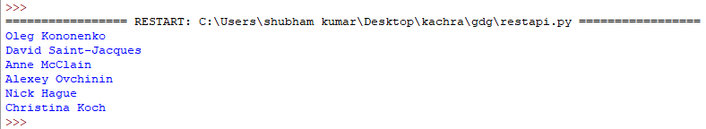

- Requesting position corresponding to current timestamp using request module.

Code

import requests
import json

position = requests.get('http://api.open-notify.org/iss-now.json')

position_2 = position.json()

print("For current timestamp ",position_2['timestamp'])
print("Latitude –“,position_2['iss_position']['latitude'])
print('Longitude -',position_2['iss_position']['longitude'])

output

- Creating earth map using basemap in python.

Code:

from mpl_toolkits.basemap import Basemap
import matplotlib.pyplot as plt

map = Basemap(projection='ortho',
lat_0=0, lon_0=0)

#Fill the globe with a blue color
map.drawmapboundary(fill_color='aqua')
#Fill the continents with the land color
map.fillcontinents(color='green',lake_color='aqua')

map.drawcoastlines()

plt.show()

Output:

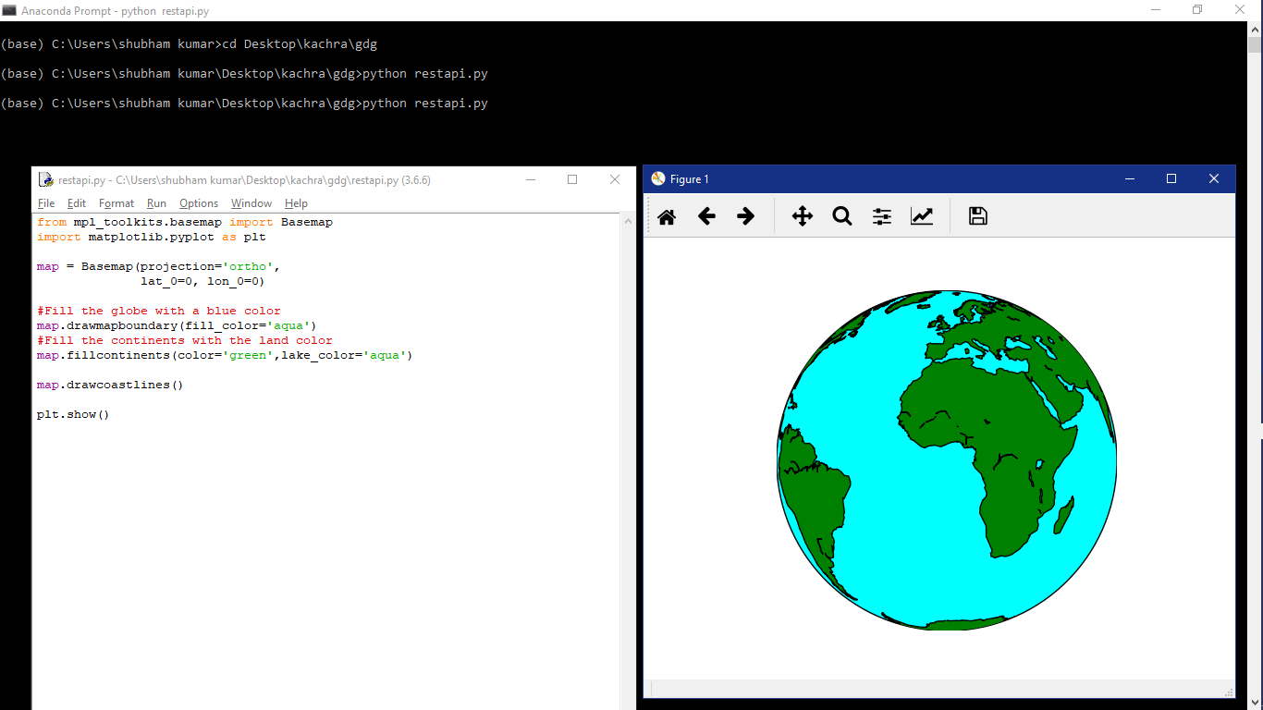

Earth Map:
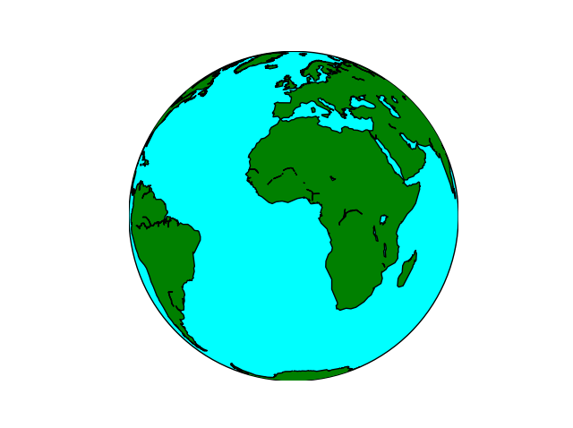
- Tracing position on earth map:

code

from mpl_toolkits.basemap import Basemap
import matplotlib.pyplot as plt

map = Basemap(projection='ortho',
lat_0=0, lon_0=0)

map.drawmapboundary(fill_color='aqua')
map.fillcontinents(color='green',lake_color='aqua')
map.drawcoastlines()

x, y = map(0, 0)

map.plot(x, y, marker='D',color='m')

plt.show()

Output:

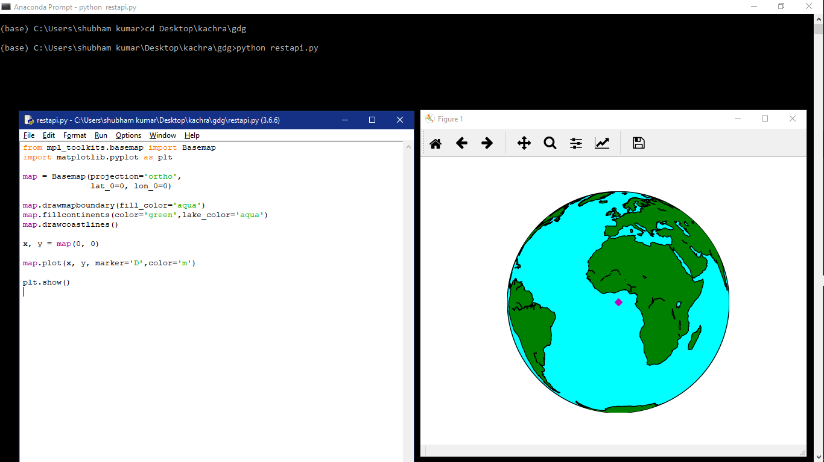

Markerd Earthmap:
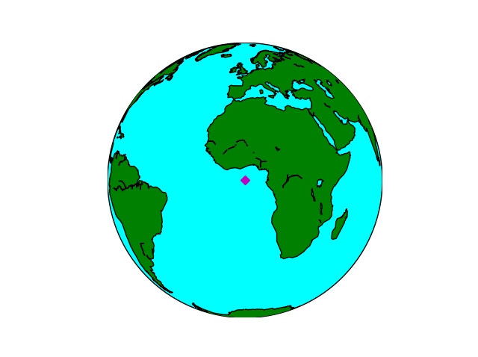

Results of execution

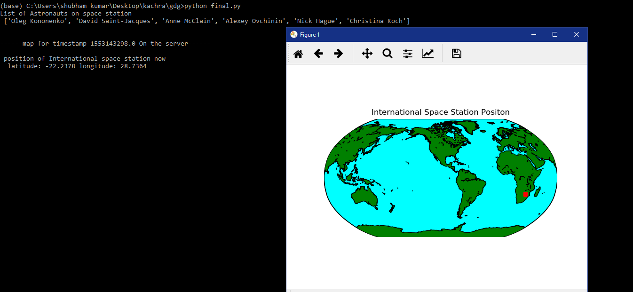

Details of the space-staion:

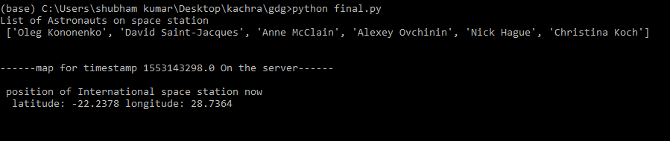

Position of the space-station:
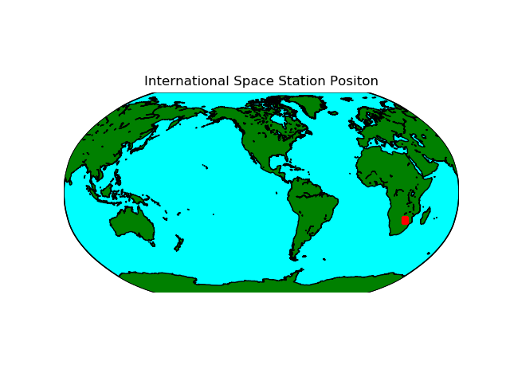
Conclusion:
This system helps in monitoring the trajectory position and plots it onto the earth map. It prints out the details of the on borders on the space station and prints time corresponding location in space in latitude and longitude.

Updating this project can bring more features to the system like plotting this system for a 3D map and visualizing the path of iss.

References:

https://matplotlib.org/basemap/users/examples.html
https://basemaptutorial.readthedocs.io/en/latest/

Appendix
Code for the system
# -*- coding: utf-8 -*-
"""
Created on Sun Mar 10 00:11:53 2019

@author: shubham kumar
"""

import requests
import json
import matplotlib.pyplot as plt
from mpl_toolkits.basemap import Basemap

def getastronauts():
##getting astronauts details using api http://api.open-notify.org/astros.json
r = requests.get(url='http://api.open-notify.org/astros.json')
data = json.loads(r.content)
A_names = []
for each in data['people']:
A_names.append(each['name'])
return A_names

def getposition():

##getting astronauts details using api http://api.open-notify.org/iss-now.json
r = requests.get(url='http://api.open-notify.org/iss-now.json')
data = json.loads(r.content)

return float(data['iss_position']['latitude']),float(data['iss_position']['longitude']),float(data['timestamp'])

def issPositionOnMap(lat, lon):

m = Basemap(projection='robin',lon_0=-105,lat_0=40,resolution='l')
m.drawcoastlines()
m.fillcontinents(color='green',lake_color='aqua')
m.drawmapboundary(fill_color='aqua')

#ploting astronauts location on base map.
x, y = m(lon, lat)
m.plot(x, y, color='red', marker='s')
plt.title('International Space Station Positon')
plt.show()

if __name__ == "__main__":
print("List of Astronauts on space station\n",getastronauts())
flag=True
while(flag):
lat, lon,timestamp = getposition()
print("\n")
print("------map for timestamp",timestamp,"On the server------\n\n","position of International space station now \n ","latitude:",lat,"longitude:",lon)
issPositionOnMap(lat, lon)

